The Digital Media Project
Source | GA09 | Date | 2006/03/19
Title | Approved Document No. 2 – Technical Reference: Architecture” | No. | 0652/Torino

Approved Document No. 2
Technical Reference: Architecture

NOTICE

Use of the technologies described in this DMP Approved Document may infringe patents, copyrights or intellectual property rights of DMP Members or non-members. Under no circumstance shall DMP be held responsible for identifying any or all such rights.

Neither DMP nor any of its Members accept any responsibility whatsoever arising out of or in connection with the use of this DMP Approved Document and the information contained herein for damages or liability, direct or consequential.

This DMP Approved Document supersedes all previous versions and is subject to change without notice.

DMP is a non profit organisation registered in accordance to the laws of Switzerland.

Copyright © 2006 – The Digital Media Project

Foreword

The Digital Media Project
The Digital Media Project (DMP) is a non-profit Association registered in Geneva, Switzerland. Its mission is “to promote the successful development, deployment and use of digital media that respect the rights of creators and rights holders to exploit their works, the wish of end users to fully enjoy the benefits of digital media and the interests of value-chain players to provide products and services, according to the principles laid down in the Digital Media Manifesto” [10].

Membership in DMP is open to any corporation and individual firm, partnership, governmental body or international organisation. DMP does not restrict Membership on the basis of race, colour, sex, religion or national origin. By joining DMP each Member agrees, both individually and collectively, to adhere to open competition in the development of digital media technologies, products or services. DMP Members are not restricted in any way from designing, developing, marketing or procuring digital media technologies, hardware, software, systems or services. Members are not bound to implement or use specific digital media standards, recommendations and specifications by virtue of their participation in DMP.

The goals of DMP are realised by developing Technical Specifications, Technical References and Recommended Practices enabling businesses that support new or improved end-user experiences and Recommended Actions to appropriate entities to act on removal of barriers holding up exploitation of digital media. Technical Specifications, Technical References, Recommended Practices and Recommended Actions are collectively called "DMP Approved Documents" (AD).

DMP operates on the basis of open international collaboration of all interested parties: corporations and individual firms, partnerships, governmental bodies or international organisations, supporting the DMP mission and the means to achieve its goals. DMP ADs are developed according to the DMP Procedures of Work [11]. DMP seeks the involvement of creators and end users of Digital Media through appropriate mechanisms.

DMP ADs are publicly available documents whose copyright is retained by DMP. DMP contributes the results of its activities to appropriate formal standards bodies and other appropriate entities whenever this is instrumental to achieve the general DMP goals. Electronic copies of DMP ADs can be obtained free of charge from the DMP web site (http://www.dmpf.org/) or from the DMP Secretariat (secretariat@dmpf.org).

DMP has the intention to make ADs available in a form such that users can implement them either freely, or on a royalty-free basis or on fair and reasonable terms and non discriminatory (RAND) conditions following the IEC/ISO/ITU policy on IPR in international standards. When issuing Calls for Proposals DMP explicitly advises Respondents to the Calls of this policy. If DMP references an external standard or specification in a DMP AD, DMP expects that the same IPR policy, or a comparable one, has been adopted by the entity that produced the standard or specification.

However, it must be noted that DMP is not in a position to make any expressed or implied guarantee that licensing of any of the technologies relevant to any or all of its ADs can indeed be obtained either royalty free, or at RAND terms.

Media and Digital Technologies
Media content has always played an important role in all societies and manifold technologies have been invented and deployed to provide means to store, distribute and consume it. The complexity of these technologies and the stimulus to provide ever-enhanced end-user experiences have created very complex media content value-chains populated by an increasing number of interacting intermediaries, each providing increasingly sophisticated services to the two extremes of the value-chains – creators and end users – as well as to the various intermediaries in between. Note that in DMP all players in the value chain – Creators, intermediaries and End-Users – are generically called Value-Chain Users or, simply, Users. Note that terms beginning with a capital letter are defined in the DMP Terminology [6].

Media value-chain technologies have been designed with two main purposes in mind: the first to provide or augment the end-user experience, and the second to provide or augment the capability to distribute media content. The latest round of technologies – the digital technologies – have augmented the end-user experience, e.g. by providing very high quality audio and video that does not deteriorate with time and use. Further digital networks have also dramatically increased the distribution potential of media content.

As a result the traditional means to manage the value of media content along the value-chain are rapidly losing their established meaning. This is the source of various difficulties and is the major cause of the poor exploitation of the potential of digital media technologies. Digital Rights Management (DRM) has been advocated by many as the set of technologies that can overcome these difficulties because Users are given the possibility to manage Content while it moves along the Value-Chain.

The Digital Media Project agrees that DRM has the potential to combine the benefit of digital technologies with the need for a virtuous circle that motivates Creators to continue creating because remuneration is facilitated by DRM technologies. However, DMP sees serious problems in the introduction of DRM technologies that are lacking Interoperability.

A DRM system can be described as a particular form of communication designed to provide controlled communication between two or more Users. Therefore the implementation of a DRM system may require a broad range of communication technologies. Unless these are designed in such a way as to enable communication of Content between two different implementations, DRM becomes an obstacle that prevent Users from having the seamless and rewarding communication that digital media technologies have enabled. This has particularly serious consequences in the case of the End-User because the lack of Interoperability detracts from the End-User experience and thus may seriously impede the take off of services designed to provide appropriate remuneration to relevant value-chain users.

Standards can bring benefits to the very special type of communication systems called DRM. However, the application of DRM standards obeys different rules because DRM is tightly connected to business practices. As the introduction of digital technologies is currently forcing changes in the way value-chain users conduct their business, it is hard to define today what kinds of standards are required, much less to forecast what kinds of standard will be needed in the future.

DMP approaches the problem of DRM Interoperability by specifying technologies – that DMP calls Tools – required to implement what DMP calls “Primitive Functions”. These are “smaller” functions obtained when the functions value-chain users perform when they do business between themselves are broken down into more atomic elements. It is expected that, while functions may undergo substantial changes as a consequence of the evolution of the media business in the value-chain, Primitive Functions will generally remain more stable.

Therefore DMP is not developing a universal “DRM standard” capable of providing interoperability between every variety of different Users in arbitrary Value-Chains or across different Value-Chains. DMP provides specifications of Tools enabling Primitive Functions along with examples of how Value-Chains serving specific goals can be set up using the standard Tools. DMP specifications are developed in phases, so as to achieve gradual development of standards technologies.

The DMP approach to DRM standardisation is based on the following process

- For each phase Use Cases deemed to be significant are identified and documented;
- Primitive Functions required to implement the selected Use Cases are singled out;
- Requirements for Primitive Functions are developed through inputs from relevant Users;
- Tools serving the needs represented by the Use Cases are standardised;
- Calls for Proposals for Tools with the identified requirements are issued;
- The Tools are selected and documented through an open process. DMP favours Tools that have already been developed, standardised or adopted by other bodies, possibly adapting them to DMP needs;
- Specifications of how Tools can be assembled to implement the selected Use Cases are developed;
- In subsequent phases, Calls for Proposals for additional Tools needed to support new Primitive Functions or additional functionalities of existing Tools are issued.

DMP calls the ensemble of all standardised DRM Tools “Interoperable DRM Platform (IDP)”. The IDP provides several major advantages:

- The specifications are industry agnostic, i.e. Users are free to build a great variety of Value-Chains that suit their business models by combining the Tools appropriate for them;
- The capabilities of a Value-Chain or new Value-Chains can be extended by adding more Tools, possibly through additional standardisation;
- The cost to access standardised Tools may be reduce because in general Tools have multiple usages and may be provided by multiple suppliers;
- Full interoperability can be achieved within a Value-Chain;
- An enhanced degree of interoperability can be achieved between different Value-Chains;
- Innovation can be continuously fed in the system.

DRM requires more than technology
In spite of the value DMP attaches to Interoperable DRM as the main digital media-enabling technology, DMP has noted that DRM has the potential to substantially alter the balance that has been in existence in the analogue world between different Users of Content, in particular when one of them is the End-User. If not appropriately remedied, this imbalance may lead to a significant reduction of the scope of Traditional Rights and Usages (TRU) of Users. A possible outcome is the outright rejection of the new technology on the part of some Users, in particular End-Users who will perceive the media experience in a DRM environment as inferior.

DMP is not claiming that an established TRU necessarily implies a right of a User to a particular Use of digital media but simply that, if Users have found a particular Use advantageous in the analogue domain, they are probably interested in continuing to exercise that Use in the digital domain as well. Leveraging upon this interest may provide multiple opportunities for new “Digital Media Business Models” that are attractive to Users but respectful of Rights Holders.

Therefore DMP intends to add technologies to its specifications to make the exercise of a broad range of TRUs technically possible. However, even a summary analysis shows that many TRUs have a legislative/regulatory impact that needs to be addressed by proper authorities. This can only be done within individual jurisdictions by determining which TRUs shall be mandated in Interoperable DRM Platforms operating under their jurisdiction and which TRUs can be left to private deals between Users. This is a challenging task because it requires blending knowledge encompassing the legal, social and economic fields with in-depth knowledge of the highly sophisticated and unusual DRM technologies.

The suite of DMP Approved Documents
DMP has produced the following ADs:

- Approved Document No. 1 – Value Chain Functions and Requirements [1]: a collection of Primitive Functions derived from today’s media value-chains with corresponding Requirements.
- Approved Document No. 2 - Architecture [2]: a general architecture that describes some of the digital extensions of today’s media value-chains and collects the basic assumptions and technologies underlying the establishment of IDP-enabled Value-Chains.
- Approved Document No. 3 – Interoperable DRM Platform [3]: a collection of technical specifications of basic Tools that are needed to implement Primitive Functions.
- Approved Document No. 4 – Use Cases and Value Chains [4]: a collection of all Use Cases along with normative specifications of examples of (portions of) Value-Chains implementing the Use Cases using the Tools drawn from the IDP Toolkit.
- Approved Document No. 5 – Certification and Registration Authorities [5]: a set of operational rules for Certification Authorities established to Certify Devices and DRM Tools, and Registration Authorities established to Assign Identifiers to Content, DRM Tools, Devices, Users and Domains.
- Approved Document No. 6 – Terminology [6]: a set of terms and corresponding definitions that are used throughout DMP ADs providedto overcome the problem of DRM being a new field that impacts many existing fields with their own established and sometimes conflicting terminologies.

In addition DMP is currently developing the following ADs:

- Approved Document No. 7 – Reference Software [7]: a software implementation of IDP Tools. DMP strives to provide the reference software as Open Source, with a license aligned to established practices. When this is not possible DMP provides the reference software with a “modify, use and distribute” license.
- Approved Document No. 8 – End-to-End Conformance [8]: a set of Recommended Practices that Value-Chain Users can reference to ascertain that the Tools employed by other parties conform to DMP Technical Specifications and Technical References.
- Approved Document No. 9 – Mapping of Traditional Rights and Usages to the Digital Space [9]: a set of example support of TRUs using DMP Tools possibly complemented by recommendations to appropriate authorities to enable the benefit of TRUs in a DMP-enabled world of digital media.

Table of contents

Foreword 2
The Digital Media Project 2
Media and Digital Technologies 3
DRM requires more than technology 4
The suite of DMP Approved Documents 5
Table of contents 7
1 Introduction 9
2 An End-to-End Value-Chain 11
2.1 A walkthrough 11
2.2 Setting up Value-Chains 12
2.3 Navigating the Value-Chain 14
3 The DMP Models 16
3.1 Creation Model 16
3.2 Distribution Model 18
3.3 Delivery Model 19
3.4 DRM Tool Model 20
3.5 Device Model 23
3.5.1 Device Identification Device 23
3.5.2 Content Creation Device 24
3.5.3 Content Identification Device 24
3.5.4 License Identification Device 24
3.5.5 DRM Tool Identification Device 24
3.5.6 Content Provider Device 24
3.5.7 License Provider Device 24
3.5.8 DRM Tool Provider Device 24
3.5.9 PAV eXternal Device 25
3.5.10 Content Consumption Device (PAV) 25
3.5.11 Content Consumption Device (SAV) 26
3.5.12 Domain Identification Device 27
3.5.13 Domain Management Device 27
3.6 Domain Model 27
3.7 Import/Export Model 29
3.8 Data Model 29
4 Platform Tools 32
4.1 Represent 32
4.1.1 Content 32
4.1.2 Identifier 32
4.1.3 Resources 33
4.1.4 Metadata 33
4.1.5 DRM Information 33
4.1.6 DRM Tool 33
4.1.7 License 33
4.1.8 Key 34
4.1.9 Use Data 34
4.2 Protocols 34
4.2.1 Identify 34
4.2.1.1 Identify Content 34
4.2.1.2 Identify DRM Tool 34
4.2.1.3 Identify Device 35
4.2.1.4 Identify User 35
4.2.1.5 Identify Domain 35
4.2.2 Authenticate 35
4.2.2.1 Authenticate Device 35
4.2.2.2 Authenticate User 35
4.2.2.3 Authenticate DRM Tool 35
4.2.3 Deliver 35
4.2.3.1 Access 36
4.2.4 Manage DRM Tool 36
4.2.5 Manage Domain 37
4.3 Package Content 37
4.3.1 DMP Content File 37
4.3.2 DMP Content Stream 37
4.3.2.1 Broadcast 39
4.3.2.2 Stream 39
5 References 41
6 Acronyms 43

Introduction
To facilitate or enable use of content by end-users, there is often the need for a string of intermediaries whose job is to make sure that content, once created, is packaged and delivered to end-users for consumption. Because intermediaries typically exchange and add value in a chain they, including creators and end-users, are also called value-chain users or, simply, users. Particularly with the use of digital technologies value-chain users tend to operate in a network and the name value-network is also used to indicate such a “non-sequential” relationship between intermediaries. In this document, however, the still more common word “value-chain” will be used.

This document contains a high-level description of the operation of a generic media value-chain based on the assumption that those who hold rights associated with content moving along the value-chain wish to retain control of the use of that content. This type of content is called “governed” content.

The description can be considered as an architecture that is shared by value-chains handling governed content. The architecture has been designed to be capable of supporting value-chains that are by and large digital extensions of today’s analogue value-chains, even though digital value-chains can be vastly different from today’s media value-chains whose origins are rooted in the prehistory of analogue media. DMP may reconsider this architecture if and when new intrinsically digital value-chains will emerge that cannot be supported by the current architecture or its extensions.

Please note the following general remarks:

- In this document words beginning with a capital letter have the meaning defined in Approved Document No. 6 – Terminology;
- The DMP architecture provides a broad view that serves to illustrate how Governed Content carrying Intellectual Property (IP) is generated, passed on through the Value-Chain and eventually consumed;
- The term User or, when stressing the importance of his role in a Value-Chain is required, Value-Chain User, will be employed to indicate a Creator, an intermediary or an End-User;
- Approved Document No. 3 – Interoperable DRM Platform provides elementary technologies (“Tools”) in the form of an Interoperable DRM Platform (IDP) that can be employed to set up Value-Chains that handle Governed Content in an Interoperable way;
- DMP specifications only address interoperability of the so-called DRM-layer, i.e. issues related to media coding and below (e.g. transport layer) are not addressed.
- DMP is continually extending the scope of the architecture and adding new Tools to the IDP toolkit.

This Approved Document No. 2 provides:

- A walkthrough exercising the main elements of Value-Chains enabled by the Tools specified in Approved Documents No. 3 and the steps required to set up Value-Chains, including the principles of operation of Authorities and Agencies in charge of Certification and Registration specified in Approved Document No. 5;
- A series of models:
  - Creation Model identifying the major entities for which IP is attributed and describing their relationship to the digital objects involved in Content Creation;
  - Distribution Model identifying and describing the role of the principal Value-Chain Users engaged in distribution;
  - Delivery Model describing the two basic ways – File and Stream – in which Content can be Delivered between Devices;
  - DRM Tool Model describing the general operation of DRM Tools in Devices;
  - Device Model identifying and describing the principal Devices employed by Value-Chain Users;
  - Domain Model describing the operation of Domains of Devices and Users;
  - Import/Export Model describing how governed content can be converted to Governed Content and vice versa;
  - Data Model identifying and describing the different types of Data specified by DMP.
- A summary description of the Tools specified by IDP-2.

Reading the Foreword of this Approved Document is a prerequisite for a proper understanding of this and other Approved Documents. It is also highly recommended that this document be read before delving in Approved Document No. 3 – Interoperable DRM Platform (IDP) [3].

An End-to-End Value-Chain

A Value-Chain is a group of interacting Users, connecting (and including) Creators to End-Users with the purpose of Delivering Content to End-Users. As indicated in the Figure below the main components are

- Creation (including Adaptation)
- Instantiation
- Production
- Content Provisioning
- Service Provisioning
- Consumption

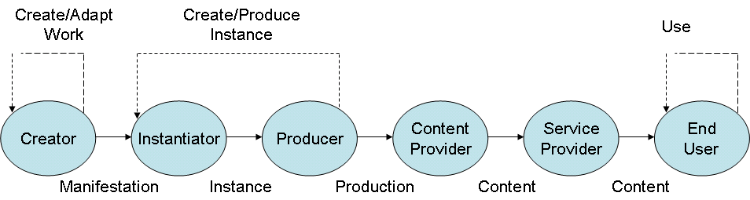

Figure 1 – Value Chain

Note that dotted arrows mean that the output of a User can be Used by the same type of User to make Resources Representing the same type of IP Entity.

A walkthrough
A Creator makes a Work that may be performed (“Instantiated”) by a performer and Used by a Producer to make a product – typically a combination of Resources – to be distributed by Content and Service Providers.

For proper management in a Value-Chain it is useful to combine different types of Resources with different types of Metadata and possibly other information types. DMP calls this combination Content. For the purpose of Using Content on Devices, Content has to be digitally Represented. DMP calls such digitally Represented Content, DMP Content Information (DCI).

A User wishing to express conditions to Use a Content Item can associate a License to it Granting Permissions under specified Conditions. The party Granting Permissions is referred to as Licensor and the party receiving them is referred to as Licensee. Approved Document No. 3 supports the case in which the Licensee is

- A Device
- A User
- A Domain.

A User who does not wish to express Conditions to Use a Content Item can do so by Releasing it without a License.

- To enable a Device to interpret Permissions without human intervention, DMP uses a machine readable language called Rights Expressions Language (REL).

To support different business models Approved Document No. 3 allows a License to be:

- Bundled within the Governed Content (i.e. it is part of the DCI)
- Not Bundled within the Governed Content (i.e. the DCI references an external License).

Approved Document No. 3 allows other Content Elements in the DCI (e.g. Resources) to be in-line or referenced.

The Content Elements in Governed Content can either be in a form that allows immediate Processing, e.g. for Rendering by a Device (so-called Clear-text) or in a protected (i.e. Encrypted) form. To this end Approved Document No. 3 provides various means to convey Keys and related DRM information.

Approved Document No. 3 provides a basic selection of Encryption Tools that can be employed in restricted-capability Devices such as Portable Audio and Video (PAV) Devices (i.e. Devices without direct access to network). However, to support a broader range of applications such as those enabled by Stationary Audio and Video (SAV) Devices (i.e. Devices with network or broadcast access), Approved Document No. 3 also provides the means to Represent in a DCI blocks of executable code (called DRM Tools or DRM Tool Packs) that are required to Process various types of Governed Content.

XML is the technology selected by DMP to Represent Content. XML is very powerful and flexible but Content Represented by means of XML can easily become bulky and unwieldy. Therefore DMP has selected an XML binarisation technology that not only reduces the size of a DCI but also allows simpler Processing in a Device without loss of information.

To Deliver Content between Device Entities it is necessary to Package a DCI (in binary form) and its referenced Resources. Approved Document No. 3 supports 2 forms of Delivery:

- As File. This is called DMP Content File (DCF);
- As Stream. This is called DMP Content Broadcast (DCB) in the case of an MPEG-2 Transport Stream, and DMP Content Streaming (DCS), in the case of Real Time Protocol on Internet Protocol.

Setting up Value-Chains
In general Users require Devices to perform the Functions proper of their role in the Value-Chain. To entrust his Content to a Device, however, a Rights Holder must have assurance that the Device will execute Functions according to Approved Document No. 3. This is achieved by having the Device Certified.

Approved Document No. 5 specifies how this task is performed by a number of organisations (Certification Agencies) that are properly appointed and overseen by a single root authority (Certification Authority). DMP appoints the Certification Authority after approving the Authority’s Certification policies. The figure below depicts this three-layer arrangement.

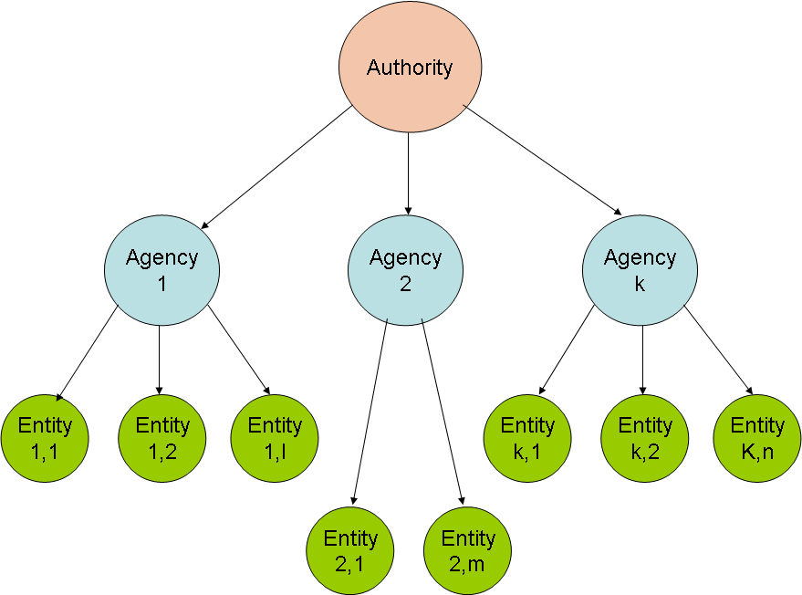

Figure 2 – Authorities appoint Agencies that Certify Entities

In general interacting Devices require the establishment of a Trust relationship between them, e.g. when they Deliver Content between them. A precondition for this to be possible is that a Device be Identified. The task of Assigning Identifiers to Devices is performed by special Devices called Device Identification Devices. Approved Document No. 5 specifies how this task is performed by a number of organisations (Registration Agencies) that are appointed and overseen by a single root authority (Registration Authority). DMP appoints the Registration Authority after approving the Authority’s Registration policies. The same three-layer arrangement used for Certification is also used for Identification.

Other Entities requiring Certification and Identification are: Domain Management Devices (Devices employed to manage Domains), DRM Tools and Users. Note that in the current phase of development Users play a role only to the extent they are represented by devices, e.g. smart cards and that Certification of such devices is out of DMP scope.

As was already the practice in the analogue world, Content Items, too, require Identification. Creators, Instantiators and Producers typically have the objects that contain their intellectual and/or commercial property (IP Entities) uniquely Identified. With Identification appropriate Metadata are also typically generated.

In summary:

- DMP Certification Authorities and Agencies are required for the following Entities:
  - Devices, e.g. Creation Devices, Consumption Devices and Domain Management Devices
  - DRM Tools.
- DMP Registration Authorities and Agencies are required for the following Entities:
  - Content – License and DRM Tool
  - Devices, e.g. Creation Devices, Consumption Devices and Domain Management Devices.

Note that only once a Device or a DRM Tool has been Certified will it be eligible to be Identified.

In general interacting Devices require Authentication to achieve Trust. Approved Document No. 3 provides Protocols that can be employed to achieve this.

Navigating the Value-Chain
The figure below places the Devices mentioned above in a generic Value-Chain and identifies their principal relationships. Note that in DMP a Device is either a combination of hardware and software – or just an instance of software – that allows a User to execute Functions.

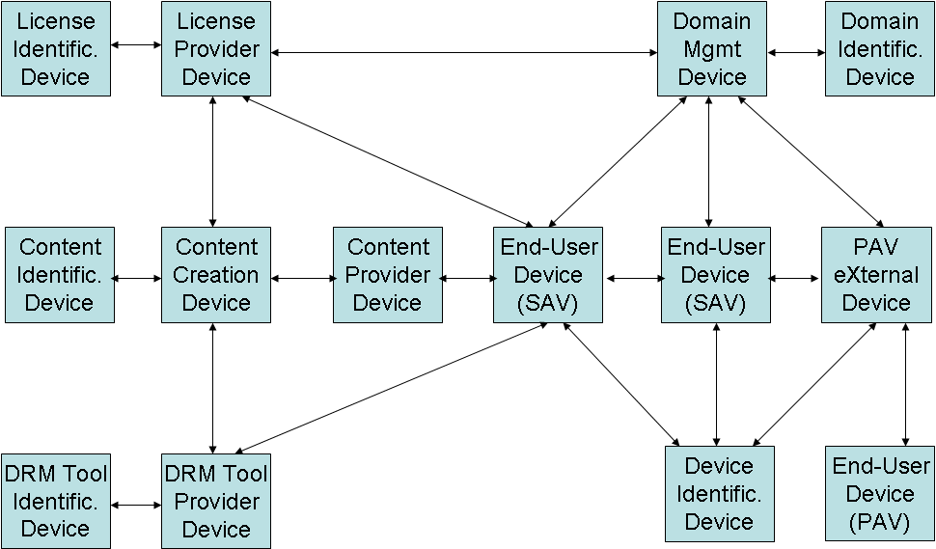

Figure 3 – Devices in a Value-Chain

The figure above will be used to describe a full walkthrough.

- Content Creation Device obtains Identifier from Identification Devices for
  - Resources (this is outside of DMP)
  - License
  - DRM Tool
  - Content
- Content Creation Device makes Content by combining:
  - Resources
  - License
  - DRM Tool
  - Identifiers
- Content is Delivered to Content Provider Device
- In case License and DRM Tool are referenced (not Bundled within the Content)
  - License is Delivered to License Provider Device
  - DRM Tool is Delivered to DRM Tool Provider Device
- An End-User Device (SAV) Accesses
  - Content from Content Provider Device
  - License from License Provider Device if Content does not have a Bundled License
  - DRM Tools from the DRM Tool Provider Device if
    - End-User Device does not already hold the required DRM Tool
    - DRM Tools are not Bundled within the Content
- End-User Device (SAV) performs the following according to License Permissions
  - Packages Content as File (DCF)
  - Adapts Resources creating DCI and DCF
  - Moves/Copies DCF to another SAV or End-User Device (PAV) via PXD.
- PXD performs the following
  - Accesses Content with Bundled Licence (as DCF) from Content Provider Device
  - If Content does not have a Bundled Licence
    - Accesses Licence from Licence Provider Device
    - Makes DCI
    - Makes DCF
  - Moves/Copy DCF to PAV

The DMP Models

Creation Model
Value-Chains begin with Content Items that represent IP Entities. In order for the management of Rights associated to IP to be consistent, Value Chains must be able to generate copies and variations of Content without breaching the sets of Rights at every point in the Value-Chain. If such an integral treatment of Rights is not achievable in a consistent and reliable fashion, then there is little hope that Rights Holders will entrust Content representing their IP to a Value-Chain. Therefore, the need to clearly identify the source of all IP and provide the means to represent all Rights associated with IP generated throughout the Value Chain is central to the DMP strategy for an Interoperable DRM Platform.

Interoperability is key to this endeavour because it enables different IP-based business models of varying scope and depth to run their full course while at the same time providing the means to determine that the Rights expressed within them are adequately supported. Furthermore, interoperability removes the possibility that some Users in the Value Chain be capable of effecting arbitrary control over other Users by virtue of restrictions inherent in the design of technology.

The purpose of the Creation Model is to provide a generic architecture for "Creation" of Content. The model should be able to represent any case where the objects representing IP are Delivered to a Device, Stored or Rendered. For IP to be identified and managed, it is required that it be embodied in human perceivable objects to be communicated, identified and associated with an actual human source. However, the ‘objects’ referred to as ‘having’ IP in this Creation Model are really independent of physical/digital objects in that their existence depends on the mind of their Creators in the first instance although only when they are ‘fixed’ in a physical form, perceivable by other human beings, can the IP be identified and communicated.

Thus, the following objects referred to as IP Entities are defined formally in the DMP Terminology and are pivotal to the DMP vision of how IP is represented by Resources.

Work
The first IP Entity identified and to which IP is attributed to in the Creation Model is Work. Work refers to the fruit of an effort undertaken by an individual or group of individuals that constitutes the logical construct that persists independently of the innumerable possible physical representations of that construct. A Work on the one hand can be very specific by being clearly identifiable through a large number of differing Manifestations all of which are perceived as being of the Work yet it is also intangible in that proof of its existence requires physically perceivable materials that are not of the Work.

Adaptation
An Adaptation of a Work is considered a new Work but is of dependent origination in that its existence depends on the existence of another independent Work. The law consistently requires that the Author of an original Work give his consent to the creation and distribution of the new Adaptation of the Work, possibly determining any set of restrictions both moral and economic. Also, the Author of an Adaptation must refer back to the root original Work. Thus, an original Work can spawn any number of Adaptations and Manifestations while an Adaptation can only spawn a singular Manifestation. Note that these requirements are only relevant for Works that are not in public domain.

Manifestation
A Manifestation is an object or event which is an expression of a Work, e.g. the original manuscript of a musical Work. It is clear that in order to establish the authorship of a Work, at least a first initial object – either digital or otherwise – must be produced and unequivocally attributed to the Author of the Work. Such objects are referred to as Manifestations. Although at least one Manifestation must be attributed to the Author of the Work, the Manifestations of Adaptations of a Work are also considered to be Manifestations of the Work. Thus, a given Work may have Manifestations attributable to other Authors.

Instance
An Instance is an object or event which is an example of an Identified Manifestation, e.g. a unique performance of a specific Manifestation of a musical Work. Instances are not necessarily uniquely of a particular Manifestation of a Work. The IP associated with Instances is so inextricably dependent on both the Manifestation and the Work that it is of, that it is classified separately as “Neighbouring” or “Performing” Rights. An Instance when it is fixated to a physical support constitutes the first copy, also referred to as “master”, used to make further copies, e.g. for commercial purposes.

Expression
An expression is the result of a process that an individual undertakes when generating a tangible Manifestation of a Work or that an Instantiator, e.g. a Performer, undertakes when interpreting a particular Manifestation to generate an Instance.

DMP does not currently define the term expression because the Creation Model is presently only concerned with classification of Content as it pertains to associating IP with digital Manifestations and Instances of Works and any attribution of IP for an expression is considered to be un-severable and correspond faithfully to the attribution given for the Manifestation and/or Instance in which they are contained. That is to say, that the owner of any IP attributable to an expression is necessarily the same person or persons to which the Manifestation and/or Instance is attributable.

Thus, in the Creation Model any object either analogue or digital that either embodies or represents IP – for the purpose of attributing IP Rights – can be classified necessarily under one of the categories as listed below in Table 1.

Table 1 – IP Objects and Rights

IP Entity | IP type | Associated Rights types
Work | Independent origination | Creator
Adaptation | Dependent origination | Creator
Manifestation | Dependent origination (Any Manifestation depends on a Work) | Creator
Instance | Unique dependent stylistic reproduction | Neighbouring or performing rights
Thus, the scope of IP associated with the different IP Entities can be summarized as in Table 2 below. Authorship of a Work (independent origination) has dominion only over all its Manifestations and all Instances, copies, reproductions and communications thereof. Authorship of an Adaptation has dominion only over all its Manifestations, Instances, copies, reproductions and communications thereof. Realization of an Instance has dominion only over all copies and reproductions thereof.

Table 2 – IP Entity Scope

 |  | Entities
 |  | Work | Adaptation | Manifestation | Instance
IP Type | Work | x | x | x | x
IP Type | Adaptation |  | x | x | x
IP Type | Manifestation |  |  | x | x
IP Type | Instance |  |  |  | x

The figure below illustrates the dependencies between IP Entities.

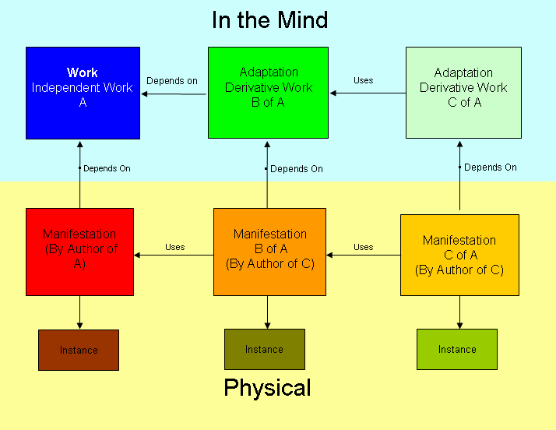

Figure 4 – IP Entity dependencies

Distribution Model
In the general DMP Distribution Model the following Users operate:

- Content Providers providing Content to End-Users and Service Providers;
- License Providers providing Licenses to End-Users and Service Providers;
- DRM Tool Providers providing DRM Tools to End-Users and Service Providers;
- Service Providers providing Services to End-Users.

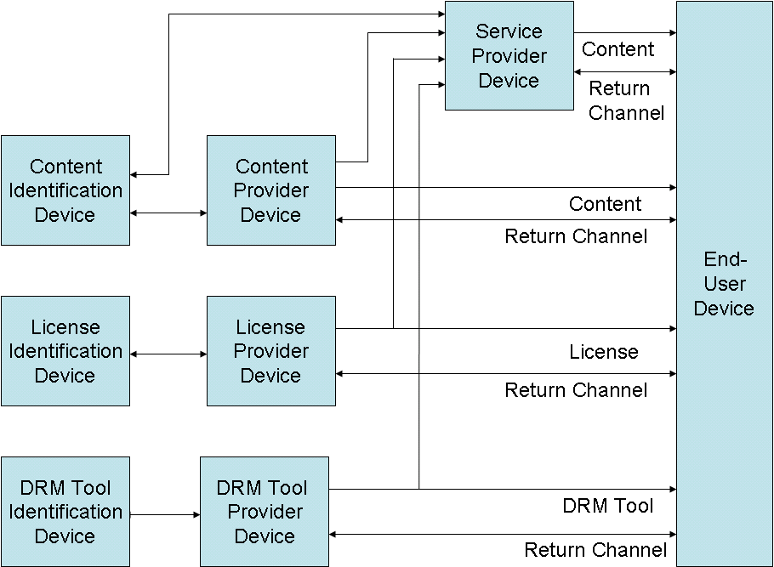

Figure 5 – Conceptual diagram of DMP Distribution Model

A specific Value-Chain need not involve all types of Users indicated in the Figure above, e.g.

- The Service Provider may Deliver Content to End-Users with License and DRM Tools Bundled within it. In this case the Service Provider makes and Registers a new Content Item out of Content, License and DRM Tools received from other Users. This is represented in the top line of the figure.
- The Service Provider may not be required as the End-User individually Accesses Content, License and DRM Tools. This is represented by removing the first line of the figure
- The DRM Tool Provider may not be required, e.g. when Governed Content is Delivered without the use of DRM Tools. This is represented by removing the bottom line in the figure.

Note that the Service Provider makes and Registers a new Content Item out of Content, License and DRM Tools that he receives from other Users.

Delivery Model
For the purpose of this specification all types of Data to be Delivered between Device Entities can be Represented as Content Elements, in particular Content, Licenses, DRM Tools and DRM Information. These Content Elements can be variously combined between themselves and other Content Elements.

DCI is a Representation of Content that, along with the relevant Content Elements, can be Processed by a Device. However, DCI is not suitable for Delivering Content between Devices. The Package Function enables Delivery of a Content Item over a variety of specific Delivery mechanisms. Approved Document No. 3 supports Delivery as a File (DCF), on an MPEG-2 Transport Stream (DCB) and on a Real-Time Protocol transport (DCS).
The Package Function includes

- Insert DCI in the selected transport mechanism
- Extract DCI from the selected transport mechanism

DRM Tool Model
The following figure describes the DRM Tool Model.

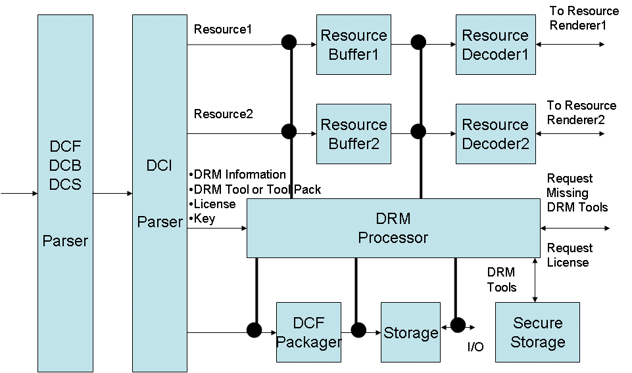

Figure 6 – Handling of DRM Tools in a Device

Packaged Content is Delivered to a Device because the Device has Accessed it or another Device has Delivered it. The Parser extracts the DCI from the Packaged Content. In general the DCI Parser extracts the following from the DCI:

- Resources
- Metadata
- DRM Information
- DRM Tools or Tool Packs
- Licenses
- Keys.

Resources and Metadata are passed to the appropriate decoding pipelines while DRM Information, DRM Tools or Tool Packs, Licenses and Keys are passed on to the DRM Processor, a module within a Device that executes DRM-related Functions in a Trusted fashion.

The Device may already have all required DRM Tools e.g. because they are:

- Embedded in the Device
- Stored after having been previously Accessed
- Bundled within the Content Item currently Accessed.

If none of the above holds, then the DRM Processor will Access the missing DRM Tools from the DRM Tool Provider Device. Once Used, all DRM Tools are kept in the Secure Storage of the Device.

The DRM Processor controls the critical points internal to a Device. As an example, in the Figure above there are 7 such “control points” (indicated as black nodes). The DRM Processor, using the DRM Information, instantiates the required DRM Tools as plug-in modules (called DRM Tool Bodies), and instructs them to operate on the specific control points along the Resource decoding pipelines.

As described above, DRM Tools represent one or more DRM Functions such as Authenticate, Decrypt, detect watermark signal or extract watermark payload, etc. The DRM Processor handles instantiation, initialisation, Authentication, and supervision of DRM Tools Bodies. However, DRM Tools can also be aggregated into a DRM Tool Group. In this case a DRM Tool Agent performs the same tasks above for the DRM Tools in a DRM Tool Group. The combination of a DRM Tool Agent and its DRM Tool Group is called DRM Tool Pack (see figure below).

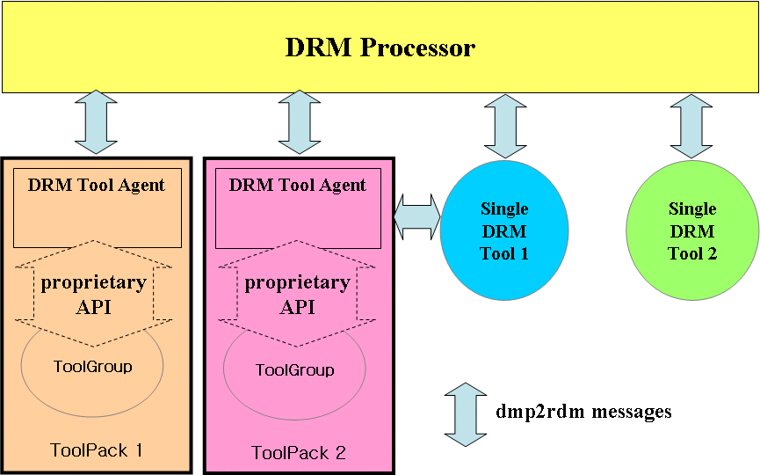

Figure 7 – Tool Pack Interoperability

Note that a mandatory requirement for a DRM Processor is that it can interface with DRM Tool Agents and DRM Tools.

By using a DRM Tool Pack, sensitive information about the way a Resource is Governed can be placed in the DRM Tool Agent instead of placing it in the DCI. However, in those cases where a simple DRM Tool configuration is required, e.g. one DRM Tool performing AES Decryption on a Governed video stream, a single DRM Tool configuration may be a simpler option.

Figure 8 and Figure 9 below graphically compare the “stand alone” DRM Tools and. the DRM Tool Pack.

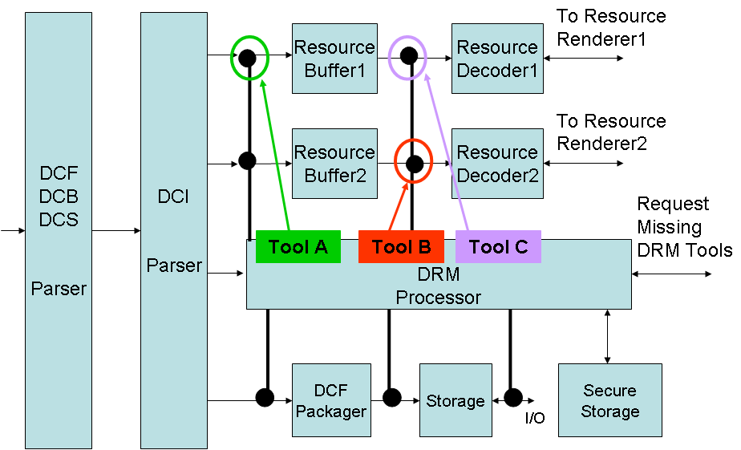 | 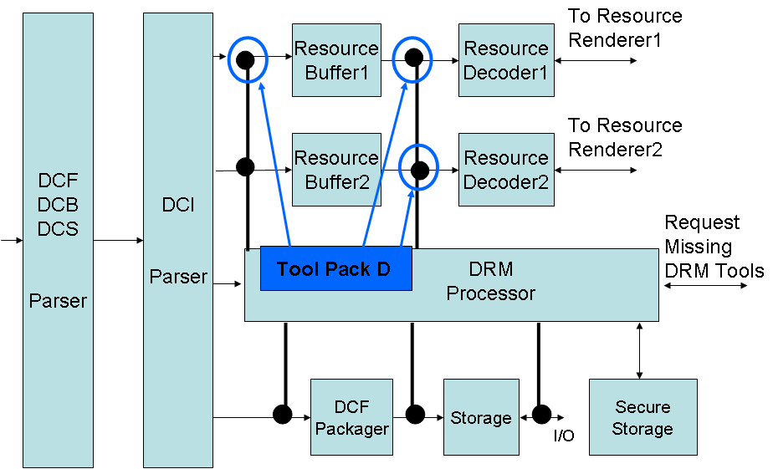
Figure 8 –“Stand alone” DRM Tools | Figure 9 – DRM Tool Pack

The following is an example of a complete walkthrough of the DRM Tool Model when a DRM Tool Pack is employed:

- DRM Tool Provider
  - Obtains DRM Tool Pack ID from DRM Tool Identification Device
  - Includes DRM Tool Pack ID in Tool Pack Information with other related Metadata
  - Makes DRM Tool Pack by combining DRM Tool Pack Information, DRM Tool Agent, DRM Tool Group and Signature
  - Stores DRM Tool Pack in DRM Tool Provider Device
- User Requests Service
- Service Provider
  - Authenticates User
  - Sends Tool Pack ID and DRM Tool Provider Device’s URL to SAV
- SAV requests Tool Pack with Tool Pack ID to DRM Tool Provider Device
- DRM Tool Provider Device Delivers Tool Pack
- DRM Processor
  - Accesses Tool Pack Information
  - Searches for requested DRM Tool Pack from Secure Storage
  - Executes DRM Tool Agent
  - Sends available Control Points to DRM Tool Agent
- If User selects more than one Service simultaneously, DRM Processor executes all Tool Agents for each service
- DRM Tool Agent instantiates DRM Tools, initializes DRM Tools, and connects each DRM Tool to proper Control Point
- If there is a missing DRM Tool in the DRM Tool Group, DRM Tool Agent requests missing DRM Tool to DRM Processor
- DRM Processor
- Searches for missing DRM Tool in the Secure Storage
- Gives the reference of the DRM Tool to Tool Agent
- DRM Tool Pack Data contains information to initialize DRM Tools in DRM Tool Group, e.g. Key information for Decryption Tool or seed number for watermarking Tool
- DRM Processor Accesses DRM Tool Pack Data and sends it to DRM Tool Agent, the only one capable of Parsing DRM Tool Pack Data
- DRM Tool Agent uses DRM Tool Pack Data to initialise the appropriate DRM Tools in the DRM Tool Group
- DRM Processor starts Resource decoding
- DRM Tools perform DRM Functions on Resources

To Update a DRM Tool Pack/Tool in SAV the DRM Tool Provider Device performs the following:

- DRM Tool Provider Device inserts a DRM Tool/Tool Pack Update message in the DCI
- DRM Processor
  - Receives Update message
  - Recognises which DRM Tool Pack/Tool should be Updated
  - If DRM Tool Body is contained in the DCI then DRM Processor replaces the Tool Body
  - Else DRM Processor Access DRM Tool Body from DRM Tool Provider
  - Updates proper DRM Tool Pack/Tool according to the Update message

Device Model
IDP-2 requires the following Device types:

Table 3 – IDP-2 Device types

# | Device Name | Acronym
 | Content Consumption Device | PAV
 | Content Consumption Device | SAV
 | Content Creation Device | CCD
 | Content Identification Device | CID
 | Content Provider Device | CPD
 | Device Identification Device | DeID
 | DRM Tool Identification Device | TID
 | Domain Identification Device | DoID
 | Domain Management Device | DMD
 | DRM Tool Provider Device | DPD
 | License Identification Device | LID
 | License Provider Device | LPD
 | PAV eXternal Device | PXD

These are briefly described below

Device Identification Device
Approved Document No. 3 supports two kinds of Device Identification:

- “Device info-based identification” in which a Device Identification Device generates the Device Identifier using some vendor specific information such as vendor ID, model ID or product serial number;
- “Certificate-based identification” in which a X.509 certificate [30], generated by a Device Identification Device, is utilised as Device Identifier.

Content Creation Device
In a typical CCD walkthrough a Creator activates an application showing a GUI displaying a series of steps that the Creator is invited to follow. Therefore a Creator:

- Selects the DCI from a number of available DCI templates
- Gets Resources with corresponding Identifiers, e.g. from outside the CCD
- Encrypts Resources (optional)
- Fills the Metadata template for each Resource
- Obtains Metadata Identifiers (optional)
- Makes a License, e.g. by selecting one from a number of available License templates
- Obtains a License Identifier from a License Identification Device
- Adds License or License information within the DCI
- Obtains Content Identifier from a Content Identification Device
- Creates a DCF
- Stores the DCF on a Content Provider Device.

Content Identification Device
The current phase of DMP specifications does not provide a Protocol for a Content Creation Device to obtain a Content Identifier.

License Identification Device
This is functionally equivalent to Content Identification Device.

DRM Tool Identification Device
This is functionally equivalent to Content Identification Device.

Content Provider Device
A Content Creation Device Delivers Content to a Content Provider Device. A Content Consumption Device (SAV or PXD) Accesses Content from a Content Provider Device employing Access Protocols specified by Approved Document No. 3.

License Provider Device
In case Licenses are not Bundled within the Content, Licenses are Stored on a License Provider Device and may be Accessed by a Content Consumption Device employing Access Protocols specified by Approved Document No. 3.

In case Content is Licensed to a Domain, the License Provider Device requests appropriate information from the Domain Management Device (see below).

DRM Tool Provider Device
In case DRM Tools are not Bundled within the Content, DRM Tools are Stored on a DRM Tool Provider Device and may be Accessed by a Content Consumption Device employing Access Protocols specified by Approved Document No. 3.

PAV eXternal Device
PAV Devices do not have network or broadcast connections to Access Content or License. However, they can be connected to a PAV eXternal Device (PXD) or a SAV, that in turn is connected to a network or broadcast channel. The following figure depicts the relationship between the four relevant Devices.

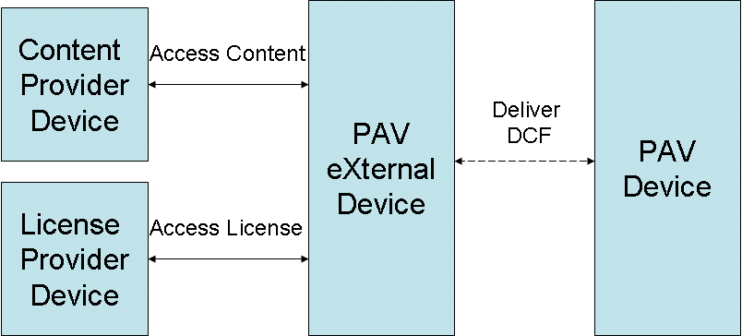

Figure 10 – A PAV and its PXD

Two cases can be considered

- In the simplest case the PXD Accesses a Content Item in the form of a DCF with a License Bundled within it. Content can then be Copied/Moved to the PAV Device, without further action by the PXD, using a Protocol that is not specified by DMP.
- If the PXD obtains a Content Item in the form of a DCF without a Bundled License, the following steps are performed:
- End-User connects his PXD to a Delivery System, e.g. Memory module, the Internet or a Broadcast channel;
- End-User activates a browser;
- End-User selects a Service;
- End-User select a Content Item (without a License Bundled within it);
- End-User Stores the selected Content in the PXD;
- End-User plugs his PAV in the PXD;
- End-User Accesses the License from License Service Provider;
- PXD Bundles the License within the Content;
- PXD makes a DCF;
- DCF is Copied/Moved to PAV as in case 1.

Content Consumption Device (PAV)
To Store Content on a PAV Device the following steps are performed:

- End-User plugs his PAV to the PXD;
- End-User activates an application on the PXD that connects the PXD to the PAV;
- The application displays a list of the DCFs on the PXD that are available for Use on the PAV;
- End-User selects the DCFs to his liking;
- End-User activates Move/Copy of those DCFs from PXD to PAV.

To Use Content on the PAV Device the following steps are performed:

- End-User activates GUI
- GUI
  - Reads the files Stored in PAV
  - Make a list using information from Metadata in each DCF
- End-User selects DCF
- PAV
  - Parses DCF to obtain DCI
  - Parse DCI to obtain
    - License
    - Metadata
    - Resource
  - Parses License to obtain DRM Information
- GUI displays the list of Functions that can be executed and Metadata
- User selects the Function
- PAV
  - Decrypts Resource
  - Decodes Resource
  - Renders Resources.

Content Consumption Device (SAV)
Once a SAV has Accessed the Content, and the necessary License and DRM Tools using the Access Protocols specified in Approved Document No. 3, it can Use the Content, e.g. Play, Store or Adapt it in the SAV or Move/Copy the Content or its Adaptation to another SAV or PAV as per License terms.

These are Functions a SAV Device performs on a Content Item, in addition to the steps listed in the walkthrough of the DRM Tool Model:

- Decrypt Resources
- Decode (decompress) Resources
- Deliver decompressed Resources for Rendering
- Create DCF with Bundled License
- Store DCF
- Move or Copy the DCF to another SAV or a PAV
- Adapt Content
- Encrypt Resources.

The figure below is a conceptual model of a SAV
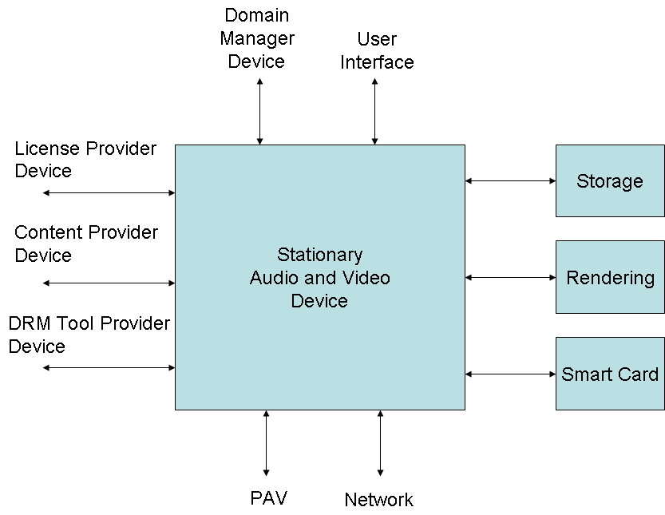

Figure 11 – Conceptual model of a SAV

Domain Identification Device
See Domain Model below.

Domain Management Device
See Domain Model below.

Domain Model
Domains are groups of Devices or Users sharing some common properties. . Using Domains it becomes possible to implement more flexible Licensing modalities, e.g. to License a Content Item to all Devices or Users in a Domain. A Domain is managed by a special Device called Domain Management Device.

The figure below represents a possible Domain configuration with:

- Two Devices (SAV), belonging to two different End-Users;
- One Device (PAV) belonging to another End-User connected to the network via a PXD;
- One Device (SAV) belonging to another End-User and remotely connected to the other Devices in the Domain via the Internet.
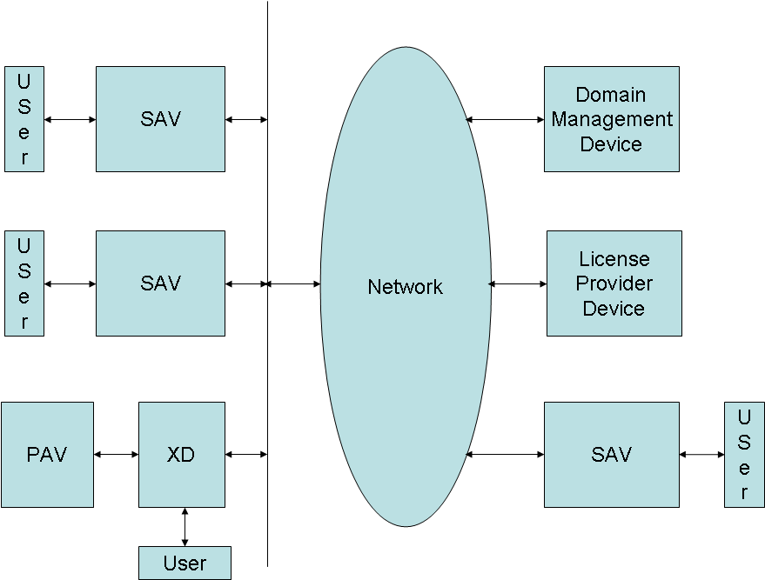

Figure 12 – An example of Domain

In general to manage a Domain 5 Device types are required:

- Domain Management Devices (DMD), to manage the life cycle of Domains and the list of Devices and Users belonging to the Domains;
- Domain Identification Devices (DoID), to Assign Globally Unique Identifiers (GUID) to DMDs on behalf of Domain Registration Agencies;
- End User Devices (EUD), e.g. SAV or PXD;
- Users, bearing in mind that Users are represented by e.g. a device (smart card etc.) or an identity on a Device (UN/PW etc.);
- License Provider Devices (LPD) to provide Licenses including for Use of Content in a Domain.

The combined operation of these Devices can be shown by a simple walkthrough in the figure below:
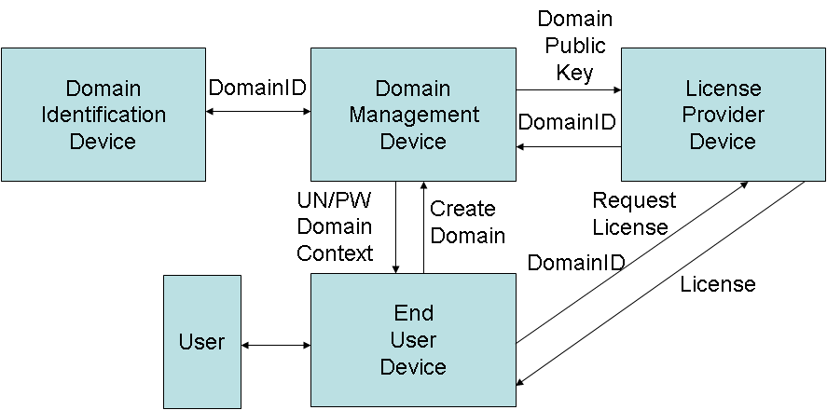

Figure 13 – The relationship of the 5 Device types in Manage Domain

- A User (Domain Administrator) requests DMD to create a Domain
- DMD
  - Creates Domain
  - Obtains Domain ID from Domain Identification Device;
  - Creates Domain Information containing Device/User list, maximum number of Devices/Users etc.;
  - Creates Domain Context for Device/User containing Domain ID, DMD ID, Domain Private Key, expiration etc.;
  - Delivers AccessID and AccessPassword to Domain Administrator;
  - Delivers Domain Context for Device/User to Device/User;
- Device/User requests License to License Provider Device giving Domain ID;
- License Provider Device sends Domain ID to DMD;
- DMD Delivers Domain Public Key to LPD;
- License Provider Device makes and Delivers License to Device/User.

Note: A Domain Management Device can manage one or several Domains. Ownership of a DMD can be implemented using a variety of mechanisms, e.g. End-User based or Service Provider based.

Import/Export Model
The DMP specifications enable Users to set up Value Chains and perform Functions in an Interoperable fashion. There may be, however, cases in which a Device needs to access governed content from a value-chain. An example, explicitly considered by Approved Document No. 3, is when a SAV accesses governed content broadcasted with a license expressed using the RMPI Rights Expression Language [31].

In this case a Device performs the following steps:

- accesses content
- translates license into a License
- makes DCF using the received Resources, Metadata and the License just made
- Stores DCF.

Approved Document No. 3 specifies the Tools to convert a license expressed using RMPI to a License.

Using a similar process a DCF with an appropriate License can be Exported to a device.

Data Model
Approved Document No. 3 specifies the Representation of the following data types:

Table 4 – IDP-2 Data types

Content | A DMP-defined structure of Content Elements, i.e. Resource, Metadata, Content, License, DRM Information, DRM Tool and Use Data
Identifier | The unique signifier Assigned by Identification
Resource | Data, whose Representation is not specified by DMP (e.g. an MP3 file or an executable code), that can be Processed by a Device
Metadata | Data that describe Content and Content Elements
DRM Information | Data that describe Governance of Content
DRM Tool | An algorithm which implements one or more DRM Functions
DRM Tool Body | An executable computer code that implements a DRM Tool
Licence | Data Representing the Permissions to a Content Entity under given Conditions expressed by Rights Expressions that are Granted by one User to another User
Key | Data used by a cryptographic method to make Clear-text Data Encrypted or, conversely, Encrypted Data Clear-text
DRM Message | A message exchanged between DRM Tool Bodies, DRM Processor and Devices
Device Information | Data characterising a Device, e.g. CPU, OS etc.
Domain Information | Data characterising a Domain that is Stored in a Domain Management Device, e.g. the list of Devices, Users, Domain Key etc.
Use Data | Data documenting the Functions performed by a Device Entity on a Content Item and the associated context
DCI Signature | Data Encrypted with a Private Key and appended to a DCI for the purpose of guaranteeing the Integrity of the DCI
DCI Hash | A number generated by applying a mathematical formula to a DCI

The following table describes which Content Elements can be contained in another Content Element

Table 5 – IDP-2 Content Elements

Content Elements | Content Elements contained
Content | - Identifier  - Resources  - Metadata  - DRM Information  - DRM Tool  - DRM Tool Body  - License  - Key  - DRM Message  - Authentication Message  - Device Information  - Domain Information  - Use Data  - DCI Signature  - DCI Hash
Identifier
Resources | - Identifier  - Metadata  - DRM Information
Metadata | - DRM Information
DRM Information | - DRM Tool  - License  - Key
DRM Tool | - DRM Tool Body  - Device Information  - DRM Message
DRM Tool Body
License | - Key
Key
DRM Message | - Key  - Authentication Message
Device Information
Domain Information | - Key
Use Data
DCI Signature | - Key
DCI Hash

Platform Tools
This section provides a high-level description of the three types of Tools specified by Approved Document No. 3: Represent, Protocols and Package.

Represent

Content
The digital Representation of Content is called DMP Content Information (DCI). The DCI is an XML structure specifying Content Identifiers, DMP-specific information, DRM information and Licenses with Content and Content Elements. See figure below for a graphical representation of a particular DCI.

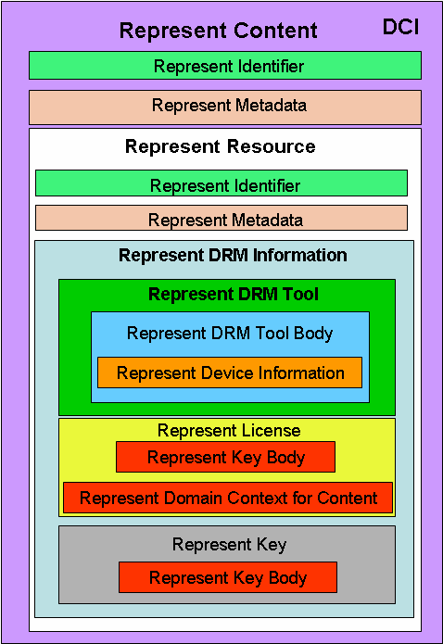

Figure 14 – An example of DMP Content Information (DCI)

Approved Document No. 3 adopts a subset of the MPEG-21 Digital Item Declaration for the DCI [21].

Identifier
To be Used in Value-Chains, Content Items should be unambiguously Identified for a given lifetime and within pre-assigned boundaries. Allocation of Identifier achieves this goal if the following aspects are guaranteed:

- Persistence, i.e. the Identifier should be used as a reference to the Content Item even beyond the lifetime of the Content Item it Identifies
- Uniqueness, i.e. the Identifier should be used across Users or globally.
Every Content Item expressed by a DCI contains a unique Identifier Assigned by a special type of User (Registration Agency). Approved Document No. 3 provides ways to Identify a Resource by means of its original Identifier inside the DCI (e.g. ISWC, ISRC) or other Metadata.

Approved Document No. 3 bases its Data Identification on the principles of MPEG-21 Digital Item Identification [22].

Resources
Resources can be typical media resources, but also DRM Tools, i.e. the executable code that is needed by a Device to Process protected Resources. As Creation and Identification of Resources are outside of the current scope of Approved Document No. 3, no Tools to Represent and Identify Resources are provided.

Metadata
Approved Document No. 3 adopts a subset of TV Anytime Metadata [31] as the default Metadata specification for Media Resources. Note that AD 3 supports the use of other metadata schemes.

DRM Information
DRM Information is the set of data resulting from implementing the rules to manage and protect any part of a DCI. It may include any information in the DCI, e.g.:

- Content Governance Information, including the signalling of the DRM Tools required to Access Content
- Decryption Keys
- Licenses
- Data for DRM Tools’ initialisation and configuration
- Appropriate Metadata
- Etc.

DRM Tool
DMP calls an executable computer code that implements a DRM Function a “DRM Tool Body”. This may be resident in a Device or contained or referenced in a DCI.

License
Approved Document No. 3 can support a wide range of business models ranging from the simple and straightforward usage models currently familiar to End-Users to innovative and possibly even speculative business models. Therefore the expression of Rights that may be required between any Users in a Value Chain and the nature and complexity of the Rights expressed may be dependent upon the role of the Users involved in this exchange.

In a Governed Content Item, the relevant Governance information is expressed within the DCI or referenced using Permissions expressed in REL statements. In order to be able to Access Governed and protected Resources, the User is required to have obtained the necessary Keys and Certificates as stipulated by the License. If the Keys are not Bundled within the DCI, they can be obtained as stipulated by the License Provider.

DMP employs two Profiles of the MPEG-21 Rights Expression Language (REL). The first (core profile) can be used in reduced-capability Devices such as PAVs. IDP-2 extends the MPEG-21 REL Dissemination and Capture (DAC) Profile [25], in order to support DMP Domain requirements.

The one-to-one association of Licenses to Content Items may entail significant logistic problems. Therefore IDP-2 also provides Tools to support alternative License distribution scenarios:

Table 6 – License Distribution Scenarios

License to | Description | Issues
1 Device | A Content Item is Licensed for Use on one specific Device. | Device requires a unique ID or certificate. Content must be re-Licensed for each new Device.
N Devices | A Content Item is Licensed for Use on multiple Devices. | Same as single Device. Reduced need to re-License Content as it can be Used on more than one Device.
Domain | A Content Item is Licensed to a Domain, i.e. Content can be Used on any Device within that Domain. | Content does not need to be re-Licensed, rather a Device needs to join the Domain. IDP-2 provides specifications for Tools to join and leave a Domain.

Key
A Key is Data used by a cryptographic method to make Clear-text Data Encrypted or, conversely, Encrypted Data Clear-text. It can be resident in a secure storage of a Device or be carried by a DCI.

Use Data
Currently DMP defines Use Data for the purpose of Domain Management.

Protocols

Identify
The following Entities require Identification:

- Content
- DRM Tool
- Device
- User
- Domain

Identify Content
Currently Approved Document No. 3 only specifies the Representation of Content Identification, not the Protocol to request Content Identification.

Identify DRM Tool
Currently Approved Document No. 3 only specifies the Representation of DRM Tool Identification, not the Protocol to request DRM Tool Identification.

Identify Device
Device Identification is used for following purposes:

Authentication | The Licence Provider needs to verify that the target Device can properly Use Governed Content, i.e. the Licence Provider needs the Device Identifier to enable Authentication
Authorisation | The Device Identifier is important information for a User with appropriate authority to allow or disallow specific Devices to Render Governed content
Domain Management | The Device Identifier is used to Identify Devices belonging to a specific Domain in which various Devices can be Registered and managed
Audit | The Device Identifier is used to Identify participant Devices on Use of Governed Content if the audit record needs to be kept
License Backup/Restore | Use of Governed Content is controlled by the License that specifies allowed Device(s). The Device Identifier is used to Identify dedicated Device on Backup or Restoration of the License

Approved Document No. 3 provides Protocols supporting two kinds of Device Identification:

- “Device info-based identification” in which a Device Identification Device generates the Device Identifier using some vendor specific information;
- “Certificate-based identification” in which a Certificate is utilised for Device Identifier.

Identify User
User Identification is outside the scope of DMP.

Identify Domain
Domain Identification is performed by a Domain Identification Device. Currently Approved Document No. 3 does not specify the Protocol for a Domain Management Device to request Domain Identification.

Authenticate
The following Entities: Devices, Users and DRM Tools need to establish Trust between themselves before they may perform DRM-related Functions.

Authenticate Device
Approved Document No. 3 specifies a Protocol to Authenticate Devices having unique Certificates.

Authenticate User
User Authentication is outside the scope of DMP.

Authenticate DRM Tool
These Protocols are currently part of Manage DRM Tool Protocols.

Deliver
The following Protocols are required by the IDP to Deliver Content. Those marked in normal are provided by Approved Document No. 3, Those marked in italic will be provided by future versions.
Table 7 – Definitions of types of Delivery

Store | The Function by which Device A Delivers Content to Device B for the purpose of retaining it in Device B for Use at a different point in time
Move | The Function consisting of the following actions  1. Copy of Content from a source Device to a destination Device  2. Deletion of said Content in the source Device
Copy | The Function that  1. Duplicates Content  2. Delivers the duplicate to another Device
Export | The Function of making available a Content Item to a non-DMP DRM system
Backup | The Function that supports  - Duplication of Content  - Duplication of Rights Expression in case this is a Stateless Rights Expression, and  - Moving the duplicate(s) to another location that is not a Device
Access | The Function executed by a Device when making Content available to so that the Device can execute Functions on it
Import | The Function of Accessing a governed content item from a non-DMP DRM system
Restore | The Function of Moving Content and the associated Stateless Rights Expression, if any, to the Device from which Backup had been performed

Access
Approved Document No. 3provides the following Access Protocols:

- Protocol to Access Content as File
- Protocol to Access License as File
- Protocol to Access DRM Tool Body as File
- Protocol to Access DRM Tool Body as Stream
- Protocols to Access Key as Stream

Additionally the following Local Access Protocols are defined

- Local License Access Protocol
- Local DRM Tool Body Access Protocol

Manage DRM Tool
To facilitate the cooperation of multiple DRM Tools to perform DRM-related Functions on Governed Resources, Approved Document No. 3 provides a message-based architecture. Such messages are XML structures allowing the exchange of information between various components of a Device, e.g. the DRM Processor and a DRM Tool, or between two DRM Tools.

The following is a non-exhaustive list of Functions enabled by the messages defined in DMP Manage DRM Tool namespace:

- A DRM Tool may require to be informed of all the other DRM Tools operating at any time
- A DRM Tool may require to be notified when a new DRM Tool is instantiated
- A DRM Tool may require the instantiation of another DRM Tool
- A DRM Tool may require the termination of another DRM Tool
- A License or any part of it may be exchanged between two parties
- A Decryption Key, along with the timing information about its use, may be exchanged between two parties
- The results of a watermarking operation may be communicated
- Two DRM Tools may mutually authenticate

Manage Domain
Approved Document #3 provides a set of protocols that can be used to manage a Domain. See Domain Model.

Package Content
For the purpose of Delivery, Content typically needs to be Packaged. Currently Approved Document #3 provides Tools to Package Content for File (DCF), Broadcast (DCB) and Stream (DCS).

DMP Content File
The file contains the DCI with some or all of the Resources it references in ‘Boxes’ defined by the ISO Base Media File Format and the MPEG-21 File Format [25]. The link between the DCI (containing Metadata and Governance information) and the Resources is done through the Item Location Box, which specifies the physical location in the file of a Resource described in the DCI.

This is represented in the figure below.
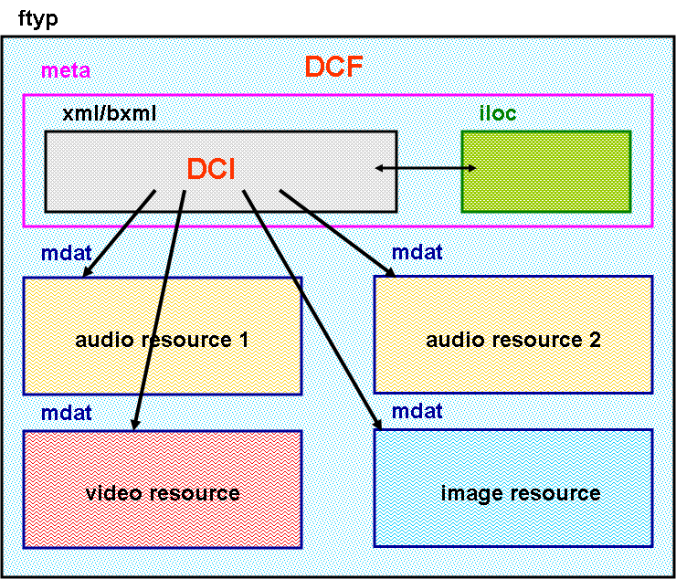

Figure 15 – Conceptual diagram of DMP Content Format (DCF)

DMP Content Stream
A number of transport mechanisms may be employed to transmit digitally Represented Content (DCI) between Devices. Currently those of highest relevance are the MPEG-2 Transport Stream (MPEG-2 TS) and the Real-Time Protocol over User Datagram Protocol over Internet Protocol (RTP/UDP/IP). When using these packet-based transmission protocols, Content must be packetised and then transmitted incrementally to the receiving Device. As Content is a combination of Content Elements, transmitting Content in a streaming fashion implies packetisation of its Content Elements.

Approved Document No. 3 specifies the means to incrementally transmit a DCI (including its component Content Elements, either referenced or included) in a piece-wise fashion and with temporal constraints in such a way that a receiving Device may incrementally Use the DCI. At the receiving end, a potentially fragmented DCI is received, where, for instance, some parts may have been removed or transformed at the transmitting end according to some rules.

Package Content as a Stream is based on MPEG-21 Digital Item Streaming (DIS) [28]. The DIS standard specifies a Bitstream Binding Language (BBL) using which it is possible to describe how a DCI may be broken down for transmission and then mapped to the transmission channels of interest: MPEG-2 Transport Streams and RTP/UDP/IP.

There are two basic types of BBL document: Instance and Binding descriptions.

- Instance describes the streaming instructions for a DCI and contains references to the DCI and any other resources of the DCI. References may be URIs, or pointers to the location of the URI within the DCI.
- Binding provides the abstract mapping of the DCI or part thereof to the particular set of output streams (MPEG-2 TS and RTP/UDP/IP). Bindings are instantiated as part of an Instance document, which provides the URI references for the fragments of Content to which the Binding(s) are to be applied.

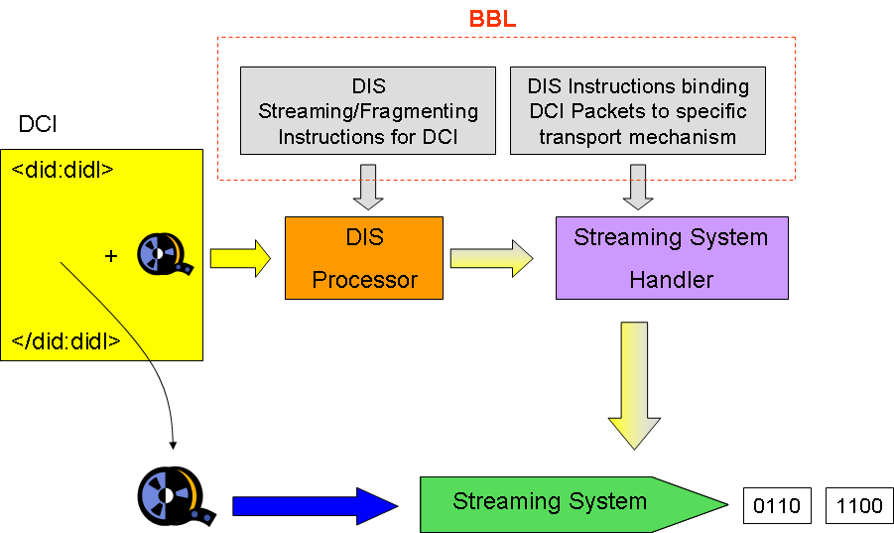

Figure 16: Streaming a DCI using Digital Item Streaming

Binding is a set of abstract Bitstream Binding Language instructions which map a DCI into a collection of packets to be output to one or more handlers, as shown the Figure above.

DIS can also be used to Package binary objects over a streaming protocol. BBL uses BS Schema from MPEG-21 Digital Item Adaptation (DIA) [25] to specify the structure of binary resources which are to be streamed using BBL. This enables fragments of a binary resource to be specified using XPath [41] references.

Broadcast
- The figure below shows an example DCI related to TV program P1.

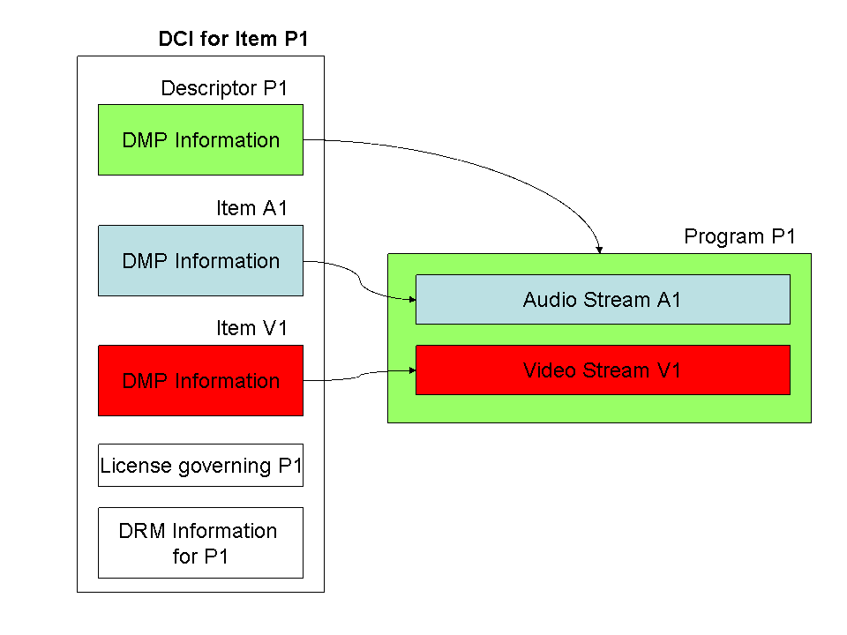
Figure 17 – Conceptual diagram of DMP Content Broadcast (DCB)

In this example Program P1 is composed of:

- Metadata of the TV program P1 (green box)
- Metadata of the video stream (DMP Infored box)
- Pointer to the video stream in the MPEG-2 Transport Stream
- Metadata of the associated audio stream (DMP Infolight blue box)
- Pointer to the audio stream in the MPEG-2 Transport Stream
- Metadata of the audio-visual stream (DMP Info)
- License of the audio-visual stream
- Metadata of the DRM Tools (DRM Info)
- The actual DRM Tools carried as Resources in the DCI.

P1 is Governed as a whole, therefore only one single license and a single DRM Information element are needed. An alternative DRM configuration not contemplated in this figure but still possible using IDP-2 Tools shows Resources Governed individually by an appropriate License and each characterised by appropriate DRM Information.

Approved Document No. 3 provides Tools to carry DCB on MPEG-2 Transport Stream.

Stream
In the figure below the DCI of Content streamed comprises

- Metadata of the streaming Content as a whole
- Metadata of the video stream (DMP Info)
- Pointer to the video stream in the RTP Stream
- Metadata of the associated audio stream (DMP Info)
- Pointer to the audio stream in the RTP Stream
- Descriptor of streaming text
- Pointer to the streaming text in the RTP Stream
- License of the Governed video stream
- Metadata of the DRM Tools (DRM Information) Governing the video Resource
- The actual DRM Tools for the Video Resource carried as Resources in the DCI.

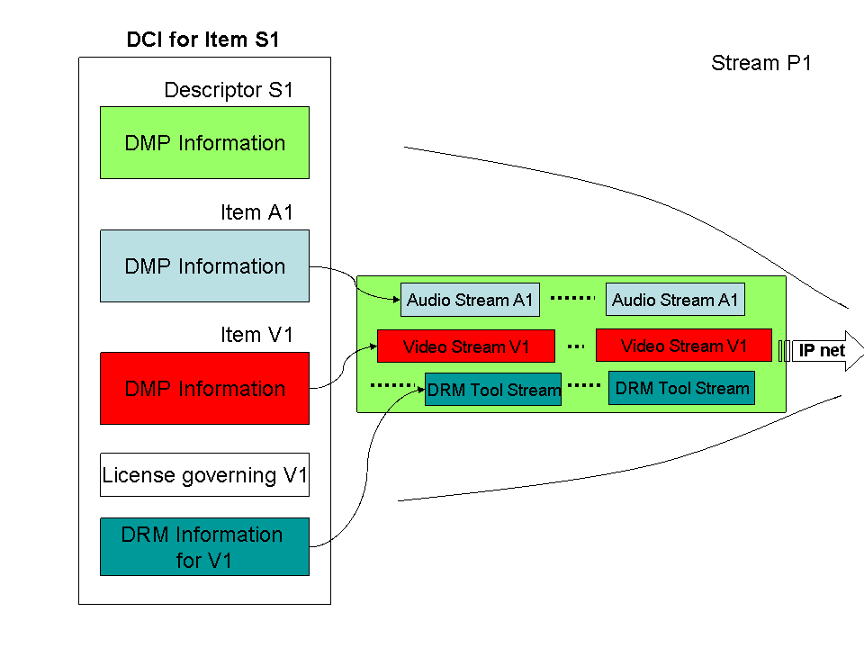
Figure 18 – Conceptual diagram of DMP Content Streaming (DCS)

Approved Document No. 3 provides Tools to carry DCS on RTP.

References
- Digital Media Project; Approved Document No. 1 – Technical Reference: Use Cases; 2005/04
- Digital Media Project; Approved Document No. 2 – Technical Reference: Architecture; 2005/04
- Digital Media Project; Approved Document No. 3 – Technical Specification: Interoperable DRM Platform; 2005/04
- Digital Media Project; Approved Document No. 4 – Technical Specification: Value-Chains; 2005/04
- Digital Media Project; Approved Document No. 5 – Technical Reference: Registration Authorities; 2005/04
- Digital Media Project; Approved Document No. 6 – Technical Reference: Terminology; 2005/04
- Digital Media Project; Approved Document No. 7 – Technical Specification: Reference Software, 2006/01
- Digital Media Project; Approved Document No. 8 – Recommended Practice: End-to-End Conformance, 2006/01
- Digital Media Project; Approved Document No. 9 – Recommended Action: Mapping of Traditional Rights and Usages to the Digital Space, 2006/01
- The Digital Media Manifesto, http://www.dmpf.org/manifesto/, 2003/09/30
- The Digital Media Project, Procedures of Work, http://www.dmpf.org/project/procedures_of_work.htm
- ISO/IEC 13818-11, Information technology – Generic coding of moving pictures and associated audio information — Part 11: IPMP on MPEG-2 systems
- ISO/IEC 14496-12, Information technology – Coding of audio-visual objects (MPEG-4) – Part 12: ISO base media file format
- ISO/IEC 14496-13, Information technology – Coding of audio-visual objects – Part 13: Intellectual Property Management and Protection (IPMP) extensions
- ISO/IEC 15938-1, Information technology – Multimedia content description interface (MPEG-7) – Part 1: Systems
- ISO/IEC 15938-2, Information technology – Multimedia content description interface (MPEG-7) – Part 2: Description Definition Language
- ISO/IEC 15938-5, Information technology – Multimedia content description interface (MPEG-7) – Part 5: Multimedia Description Schemes
- ISO/IEC 15938-9, Information technology – Multimedia content description interface – Part 9: Profiles and levels
- ISO/IEC 15938-10, Information technology – Multimedia content description interface (MPEG-7) – Part 10: Schema Definition
- ISO/IEC 15938-11, Information technology – Multimedia content description interface (MPEG-7) – Part 11: MPEG-7 Profile Schemas
- ISO/IEC 21000-2, Information technology – Multimedia framework (MPEG-21) – Part 2: Digital Item Declaration
- ISO/IEC 21000-3, Information technology – Multimedia framework (MPEG-21) – Part 3: Digital Item Identification
- ISO/IEC 21000-4, Information technology – Multimedia framework (MPEG-21) – Part 4: IPMP Components
- ISO/IEC 21000-5, Information technology – Multimedia framework (MPEG-21) – Part 5: Rights Expression Language
- ISO/IEC 21000-5 Amd 2, Information technology – Multimedia framework (MPEG-21) – Part 5: Rights Expression Language, Amendment 2, Dissemination & Capture (DAC) Profile
- ISO/IEC 21000-7, Information technology – Multimedia framework (MPEG-21) – Part 7: Digital Item Adaptation
- ISO/IEC 21000-9, Information technology – Multimedia framework (MPEG-21) – Part 9: File format
- ISO/IEC 21000-18, Information technology – Multimedia framework (MPEG-21) – Part 18: Digital Item Streaming
- ISO/IEC 23001-1, Information technology – MPEG Systems Technologies (MPEG-B) – Part 1: Binary MPEG format for XML
- ITU-T Recommendation X.509 | ISO/IEC 9594-8 Information technology – Open Systems Interconnection – The Directory: Public-key and attribute certificate frameworks, March 2000
- ETSI TS 102 822-3-2 V1.3.1 (2006-01); Broadcast and On-line Services: Search, select, and rightful use of content on personal storage systems ("TV-Anytime"); Part 3: Metadata; Sub-part 2: System aspects in a uni-directional environment
- ETSI TS 102 822-5 v1.1.1; Broadcast and On-line Services: Search, select, and rightful use of content on personal storage systems ("TV-Anytime Phase 1"); Part 5: Rights Management and Protection (RMP) Information for Broadcast Applications
- IETF RFC 1737, K. Sollins and L. Masinter, Functional Requirements for Uniform Resource Names, December 1994.
- IETF RFC 2045, N. Freed and N. Borenstein, Multipurpose Internet Mail Extensions, November 1996
- IETF RFC 2616, R. Fielding, J. Gettys, J. Mogul, H. Frystyk, L. Masinter, P. Leach and T. Berners-Lee, Hypertext Transfer Protocol -- HTTP/1.1, June 1999
- IETF RFC 2141 R. Moats, URN Syntax, May 1997
- IETF RFC 2459, R. Housley, W. Ford, W. Polk, D. Solo, " Internet X.509 Public Key Infrastructure Certificate and CRL Profile", January 1999
- W3C Recommendation, “XML-Encryption Syntax and Processing”, 10 December 2002. http://www.w3.org/TR/xmlenc-core/
- W3C Recommendation, “XML-Signature Syntax and Processing”, 12 February 2002. http://www.w3.org/TR/xmldsig-core/
- W3C Recommendation, “XML SchemaXML Schema Part 1: Structures Second Edition , 28 October 2004”, http://www.w3.org/2001/XMLSchema
- W3C Candidate Recommendation, “XML Path Language (XPath) 2.0”, 3 November 2005, http://www.w3.org/TR/xpath20/

Acronyms
Acronym | Meaning
AD | Approved Document
BBL | Bitstream Binding Language
CCD | Content Creation Device
CID | Content Identification Device
CPD | Content Provider Device
DCB | DMP Content Broadcast
DCF | DMP Content File
DCI | DMP Content Information
DCS | DMP Content Streaming
DeID | Device Identification Device
DIS | Digital Item Streaming
DoID | Domain Identification Device
DMD | Domain Management Device
DPD | DRM Tool Provider Device
DRM | Digital Rights Management
IDP | Interoperable DRM Platform
GUI | Graphical User Interface
IP | Intellectual Property
IP | Internet Protocol
LID | License Identification Device
LLAP | Local License Access Protocol
LPD | License Provider Device
PAV | Portable Audio and Video (Device)
PKI | Public Key Infrastructure
PXD | PAV eXternal Device
RCAP | Remote Content Access Protocol
REL | Rights Expression Language
RLAP | Remote License Access Protocol
RMPI | Rights Management and Protection Information
RTP | Real Time Protocol
SAC | Secure Authenticated Channel
SAV | Stationary Audio and Video (Device)
TPD | DRM Tool Provider Device
TRU | Traditional Right and Usage
TS | (MPEG-2) Transport Stream
UDP | User Datagram Protocol
URI | Universal Resource Identifier
XML | eXtensible Markup Language

